Anthony Bugatto

April 27, 2018

Coupled BPF

This lab was to design and simulate 2GHz coupling band pass filter on sonnet. The design used the chebychev .5dB equal ripple parameters for the filter design and Rodgers 5880 and copper for the design materials. Figure 1 shows the sonnet design for the filter and Figure 2 shows the 3D model of the filter given the materials and geometry of the stripline. Figure 3 shows the current density of the filter at 1.5GHz, 2GHz, and 2.5GHz. We can see that at 1.5GHz and 2.5GHz the current is reflected at the input while at 2.0GHz the current is minimally reflected just like the theory would suggest. Figure 4 shows the frequency response. We can see that the center frequency has shifted a little through the design process and is now roughly 1.9GHz instead of 2.0GHz. This isn’t too much of a problem and if we were to implement the system in hardware we could optimize by scraping off or adding stripline until it works. Additionally, we can see that S11 reflects back almost all of the signal and ripples the current through the pass band while S21 attenuates for almost all but the pass band. Overall, this project was a success.

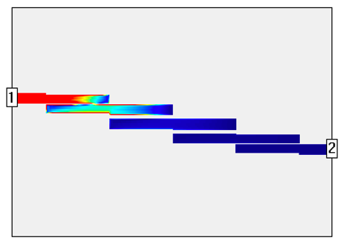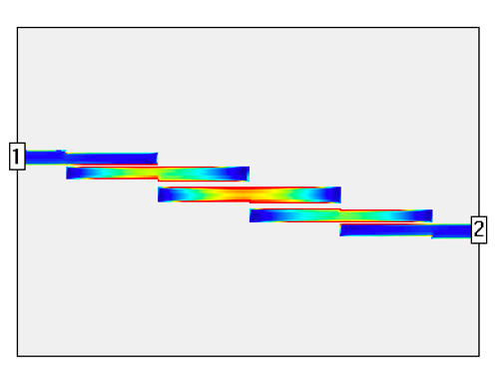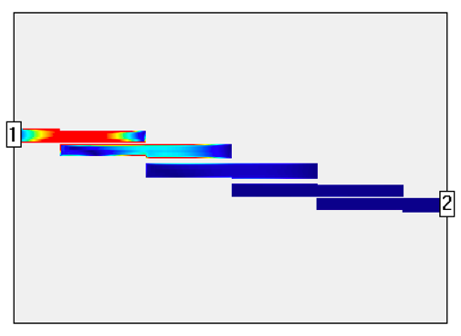

Figure 3: Sonnet Current Intensity for 1.5GHz, 2.0GHz, and 2.5GHz

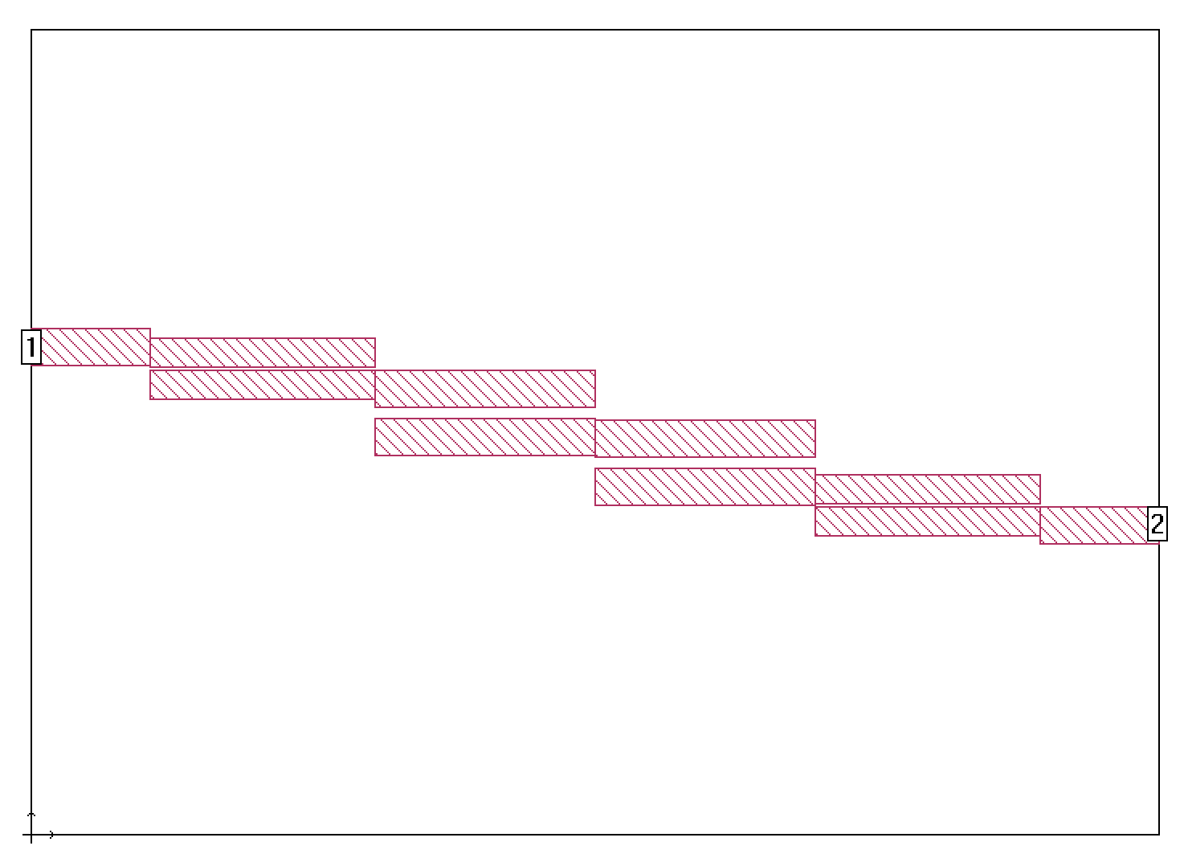

Figure 1: Sonnet workspace

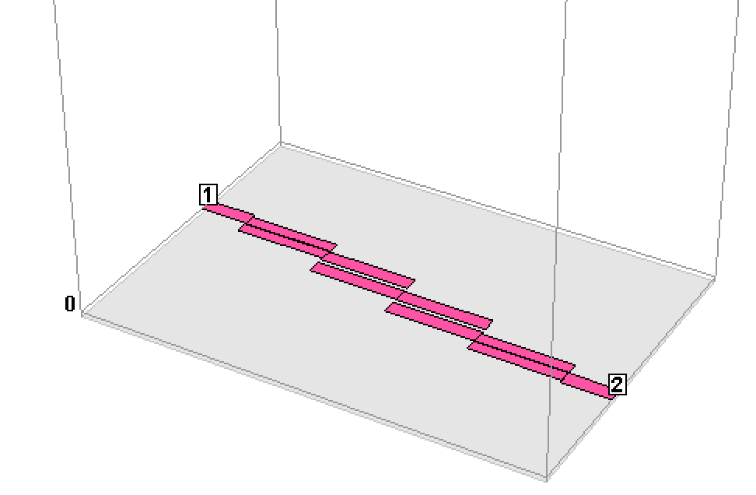

Figure 2: Sonnet 3D Model

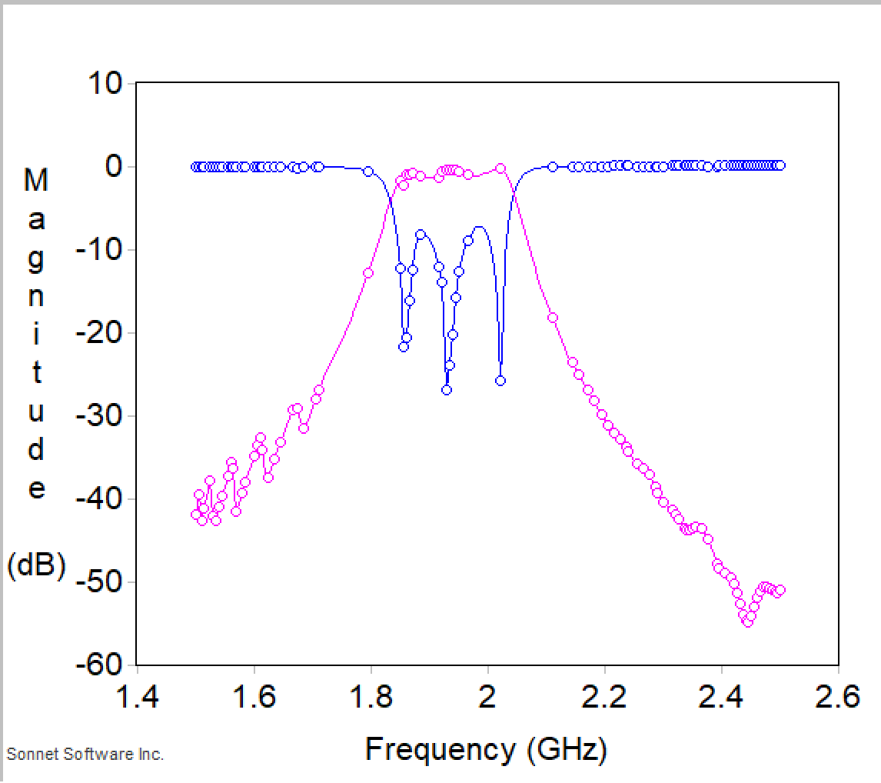

Figure 4: Magnitude Graph for S11 (blue) and S21 (red)